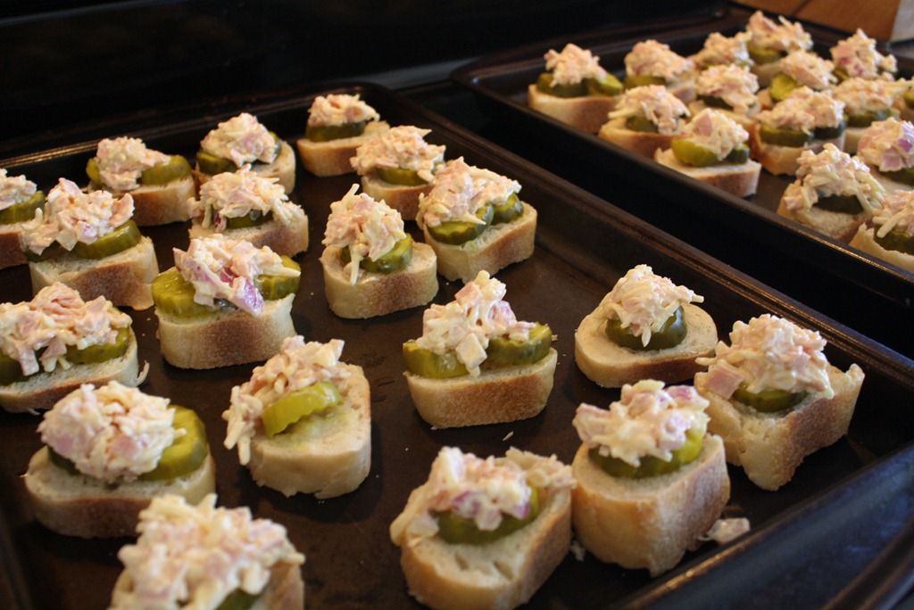
Cuban Toasties

1 1/2 ounces boiled deli ham slices, finely chopped (1/2 cup)
3 ounces shredded swiss cheese
(3/4 cup)
1/3 cup mayonnaise
1/2 small onion, finely chopped
1 1/2 teaspoons chili sauce
1 teaspoon yellow mustard
1 baguette, cut into 1/2-inch thick slices (or 5 slices white sandwich bread, quartered)
2-3 crisp dill pickles, thinly sliced

1. Preheat the oven to 500°.

2. In a small bowl, combine the ham, cheese, mayonnaise, onion, chili sauce, and mustard.

3. Arrange the bread slices on a foil-lined baking sheet.

4. Place 2 pickle slices on each bread slice; then spread about 1 tablespoon of the ham mixture on top.

5. Bake for 8-10 minutes or until gold and bubbly.

6. Cool a few minutes before serving.

